**CHATBOT DEPLOYMENT WITH IBM CLOUD WATSON ASSISTANT**

|  |  |
| --- | --- |
| **Date** | **06-10-2023** |
| **Team ID** | **676** |
| **Project Name** | **Chatbot Deployment with IBM Watson Assistant** |

**Table of Contents**

|  |  |
| --- | --- |
| 1 | Introduction |
| 2 | Problem Statement |
| 3 | Design and Innovation Strategies |
| 3.1 | User Centric Design |
| 3.2 | Natural Language Understanding(NLU) |
| 3.3 | Contextual Conversations |
| 3.4 | Advanced Features Utilization |
| 3.5 | Multimedia Integration |
| 3.6 | Iterative Testing and Refinement |
| 3.7 | Analyzing user feedback |
| 4 | Conclusion |

**1. Introduction**

In today's fast-faced digital world, businesses and organizations are constantly seeking innovative ways to engage with their audience, provide quick access to information, and enhance customer experiences. One such solution is the creation of a helpful virtual guide using IBM Cloud Watson Assistant. This virtual guide can be customized to assist users on popular messaging platforms like Facebook Messenger and Slack, offering a friendly and informative conversational experience.

**2. Problem Statement**

Create a helpful virtual guide using IBM Cloud Watson Assistant. Customize the chatbot to assist users on popular messaging platforms like Facebook Messenger and Slack. Provide useful information, answer FAQs, and offer a friendly conversational experience. Empower users with quick access to information and create meaningful connections through your virtual guide.

**3. Design and Innovation Strategies**

**3.1. User Centric Design**

Innovation: Understanding user behaviour, preferences, and creating an intuitive and effective chatbot interface.

User-centric design is a fundamental principle for creating a successful chatbot deployment with IBM Watson Assistant. It places the needs and preferences of users at the forefront of the design process.

This involves conducting user research, gathering feedback, and creating user personas to inform the design decisions. Clear and concise language should be used in the chatbot's responses to ensure users understand and trust the system.

Continuous user testing and feedback loops are essential for refining the chatbot's design and functionality, ensuring it evolves to meet changing user needs. Ultimately, a user-centric approach leads to a chatbot that provides a positive and satisfying user experience.

**3.2. Natural Language Understanding(NLU)**

Innovation: It empowers the chatbot to comprehend and interpret human language, allowing it to discern user intent, entities, and context.

By utilizing NLU, the chatbot can provide more accurate and contextually relevant responses, enhancing the overall user experience. IBM Watson Assistant employs advanced NLU algorithms that can extract valuable information from user input, enabling the bot to perform tasks or provide information effectively.

Training the NLU model involves providing ample examples of user inputs and their corresponding intents and entities, allowing the system to learn and adapt over time. Ultimately, NLU plays a pivotal role in making the chatbot a sophisticated and effective tool for natural language conversations.

**3.3. Contextual Conversations**

Innovation: Capable of handling dynamic and nuanced conversations

Contextual conversations are a vital feature in chatbot deployment with IBM Watson Assistant. They enable the chatbot to remember prior interactions, creating a more coherent and personalized user experience.

IBM Watson Assistant offers tools like context variables, allowing the bot to retain information across multiple turns, enhancing its ability to handle complex dialogues.

Designing for contextual conversations involves careful planning of how information is stored and utilized throughout the interaction, ensuring a seamless and engaging user experience.

**3.4. Advanced Features Utilization**

Innovation: It enables the bot to gather specific information from the user, making it adept at handling complex queries.

Leveraging advanced features is pivotal in creating a robust chatbot deployment with IBM Watson Assistant. These features, including system entities, slots, and digressions, offer enhanced capabilities for more sophisticated interactions.

System entities allow the chatbot to recognize common types of information like dates, numbers, and locations, streamlining user input interpretation.

Digressions allow the chatbot to temporarily shift focus to address related topics before returning to the main conversation. By harnessing these advanced features, the chatbot becomes more versatile and capable of handling a broader range of user queries, ultimately enhancing the overall user experience.

**3.5. Multimedia Integration**

Innovation: It helps to align with project goals and target audience

Ensure compatibility with popular platforms like Facebook Messenger, Slack, or WhatsApp, among others. Utilize IBM Watson Assistant's built-in features or provided connectors to seamlessly connect with these messaging platforms.

Customize the chatbot's responses and behaviour to suit the specific requirements of each platform, adapting to the unique user base and communication style. Conduct thorough testing to verify the chatbot's performance and responsiveness within the chosen messaging platforms, addressing any potential issues or discrepancies.

Monitor user engagement, feedback, and analytics on each platform to refine the chatbot's performance and optimize its conversational abilities.

**3.6. Iterative Testing and Refinement**

Innovation: It analyses the understanding and responding of chatbot based on the user inputs

This process involves cyclically testing and improving the chatbot's performance based on actual user interactions and feedback. Valuable user feedback is collected and analyzed, pinpointing areas for improvement.

Adjustments are made to the chatbot's intents, entities, and dialogue flow to address identified shortcomings. This refined version is then tested again, creating a continuous loop of enhancements.

Through this iterative process, the chatbot evolves dynamically, ensuring it consistently delivers an optimal user experience.

**3.7. Analysing User Feedback**

Innovation: Enhancing user friendly chatbot

User feedback is invaluable in creating an effective chatbot deployment with IBM Watson Assistant. It provides direct insights into user experiences and helps identify areas for improvement. Encourage users to share their thoughts on the chatbot's performance, including its accuracy, responsiveness, and overall usability. Analyze this feedback to identify common pain points and recurring issues.

Note: In the diagram below, we've depicted the key components and interactions described in sections 3.1 to 3.7, offering a clear and concise overview of our solution architecture. This visualization simplifies the complex concepts and relationships discussed in those sections, making it easier for the reader to grasp the overall design and innovation strategies at a glance.

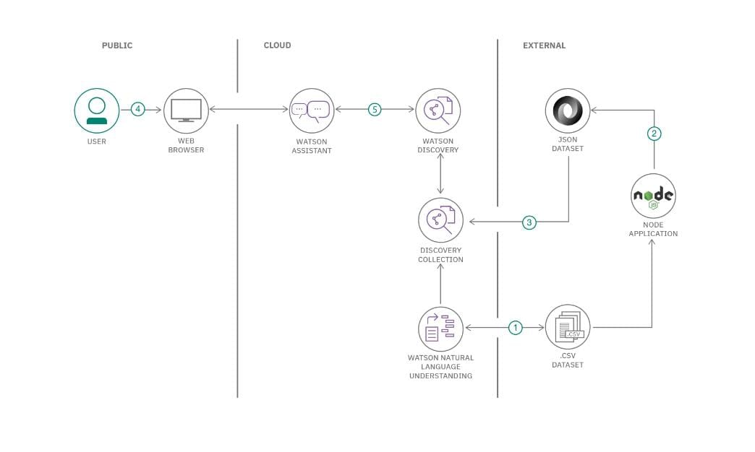

**4. Conclusion**

In Summary, by leveraging the power of IBM Watson Assistant, we enable the chatbot to comprehend user intent with precision, resulting in more effective conversations. The integration with popular platforms like Facebook Messenger and Slack ensures widespread accessibility, meeting users where they are most active. Customizing responses and behavior for each platform showcases a tailored approach, resonating with diverse user groups. Thus the, chatbot becomes a valuable asset, streamlining interactions and revolutionizing user experiences on Facebook Messenger and Slack.